**EGR 4810 Project 1**

**Date:** 11/16/19, Saturday, week 13

**Due Date:** 12/2/19, Monday, week 15

**Total Grade Points**: 6 grade points

Note Project 1 of 6 grade points plus project 2 of 14 grade points constitute 20 grade points.

In this class, you have groups for EGR 4810 to do exercises and However, you are taking EGR 4820 with another instructor or with me. **You all have done presentations or will do presentations with your EGR 4820 group** (where some group member(s) may be in this EGR 4810 class or some group member(s) may be in other EGR 4810 class).

In this project you are writing a Word report for your EGR 4820 project where some members of your project may not be in this class.

**Write** a project report in Word (not Power Point. However, you can use your information or pictures etc. from your PowerPoint file).

1. **Explain** what your EGR 4820 project is (in about 3 paragraphs, using texts, diagrams, pictures etc.). Show the project title / topic, the field (in computer, in communications etc.).

Sodar Definition: Sound Detection and Ranging

Is a technology that uses

It’s a technology that makes it possible to measure different profiles with the help of sound. It works in the same way as a radar system but sends out sound waves, instead of radio signals, for detection.

By measuring the scattering of sound waves, sodar provides the user with information regarding atmospheric turbulence.

We will be projecting sound from an Arduino , pickingthesound up with another aduino and then transmiting the data to a laptop over wifi which will be analyzed by our UI

What we will be doing:

Constraints

* Cost
* Scope/Quality
* Attenuation of soundwaves over distance limits how far we can detect items from
* Doppler effect makes it difficult to detect multiple etems when they are in line

Differences

* Distinction Between SOund Detection And Ranging and RADAR
  + PHOTOS – use venn diagram
* Transmits high frequency chirps which are received by the speaker

Interface

* Create an on computer mockup in photoshop
  + PHOTOS

Project Overview

* Speaker -> Object -> Microphone -> Arduino -> Wifi -> Application
  + Create easy visual
* Gain understanding about how we will be setting up the system
  + Connecting to wifi and controlling Arduino via that
    - See ***port forwarding?***

**Design Decision and Contributions**

Hardware

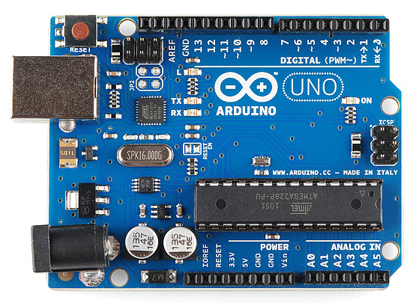

Figure 2. Arduino

* 9 volt battery
* Arduino
* Ultrasonic Sensor
* Laptop
* Platform with rotating top where we can place Arduino and Sensor
* Motor to rotate top

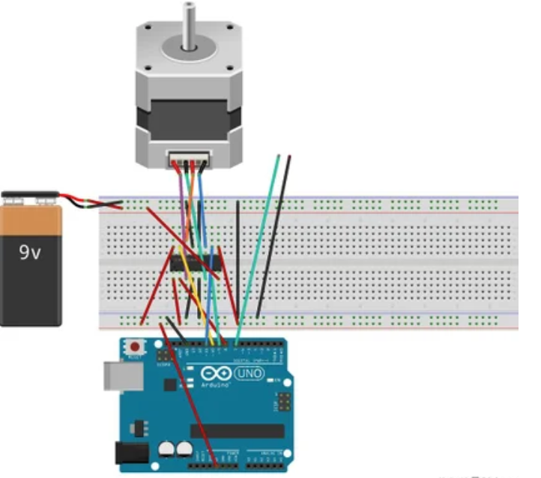

Figure 3. Rotating top Assembly

User Interface

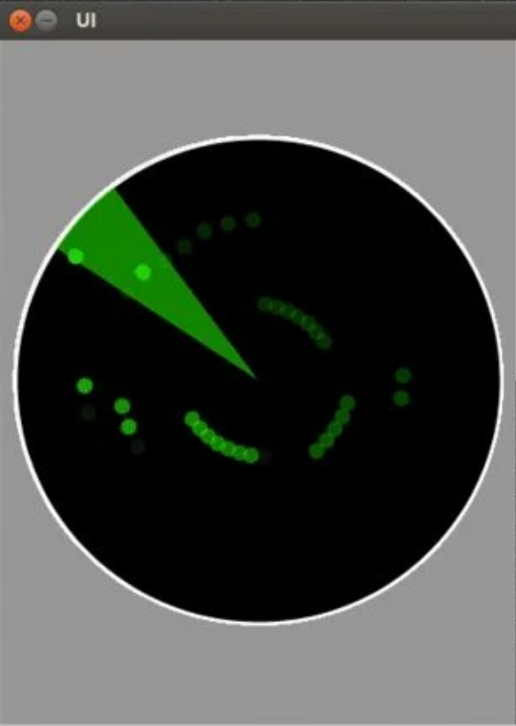

Figure. 4 User Interface

* User interface will display objects detected by the SODAR device via LabVIEW.

1. **Show** the organization of your project including your 4820 advisor (instructor), students who may be or may not be in this 4810 class. Are there students from any other departments (such as Mechanical Engineering)?
2. **Update** the progressand status if any from the date of your EGR 4820 presentation about your project at this moment.

At this moment we are behind our earlier goal as we were slowed by issues relating to receiving our components thus we have not ben able to build the physical components of our project however we’ve adjusted and we will be doing so over break.

1. **Explain** the contributionto your EGR 4820 projectfrom all your group member(s) in this EGR 4810 class (you may be the only one or the only two etc. of your EGR 4820 group in this class).

1. Do you (one person or many of you) have any good time working with your group members in this class or your group members in other instructors’ classes? Explain!

In this class specifically I was added to a group late and for the first two assignments I didn’t make a contribution however as the semester went on I became more consistent As for my “4820” our group works rather cohesively

1. Do you have conflict or complaints with your group members in this class or in other classes? If there is, how do you all members of EGR 4820 group resolve?

There has not been any conflict within the group thus far however I feel that if our group were subject to conflict it would be addressed and handled with a mutual respect for one another as well as the project. We all understand that we are senior and we will work together to complete our project as well as our degrees thus any conflict would likely be to ensure that remains true for everyone.

1. Do you think your group is a strong group and you will do well to complete your project by spring next year?

Yes, I believe once we receive our parts our general productivity will be vastly increased,

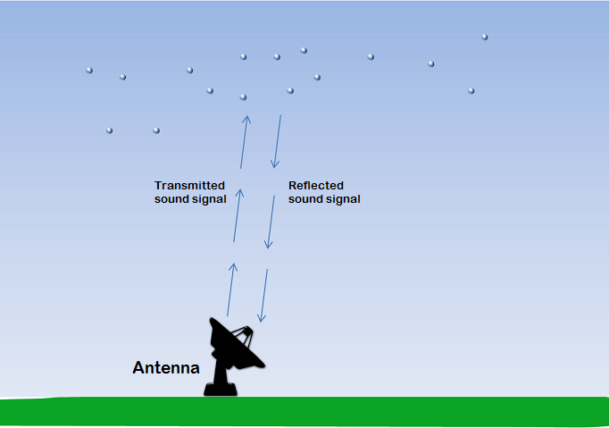As for weaknesses I feel that I personally was lacking in communication in the beginning as I was added to the group late and I had to bring myself to speed, however looking towards this winter break and the upcoming semester will be the time that we will be

